Solution Architecture

Introduction
The Solution Architecture defines the overall structure of the Metro Ticket Generating System developed on the ServiceNow platform. It illustrates how different ServiceNow modules work together to automate metro ticket booking, fare calculation, QR code generation, and database management. The architecture has been designed to provide a secure, scalable, and maintainable solution using low-code development practices.

Architecture Overview
The Metro Ticket Generating System follows a layered architecture where each layer performs a specific responsibility. The Presentation Layer allows passengers to interact with the application through the Service Portal. The Application Layer processes business logic using Service Catalog, Catalog Client Scripts, UI Policies, and Flow Designer. Finally, the Data Layer stores booking information in the Metro Database while Access Control Lists (ACLs) ensure secure access to records.
This layered approach separates user interaction, business logic, and data management, making the application easier to maintain and enhance in the future.

Architecture Components

Presentation Layer
The Presentation Layer consists of the Service Portal, which provides a simple and responsive interface for passengers. Users access the Book A Metro Ticket catalog item, enter their journey details, and submit the booking request. UI Policies improve the user experience by displaying relevant fields dynamically, while Client Scripts validate the entered information before submission.

Application Layer
The Application Layer contains the business logic of the system. Catalog Client Scripts automatically calculate fares based on the selected stations and journey type. Flow Designer processes booking requests by retrieving catalog variables, creating records in the Metro Database, and triggering QR code generation. This layer eliminates manual intervention and ensures that every booking follows the same workflow.

Data Layer
The Data Layer stores all booking information in the custom Metro Database table. Each booking record includes passenger details, station information, journey type, fare amount, travel date, and booking status. Role-Based Access Control (ACLs) protect the stored information by allowing only authorized administrators to access or modify database records.
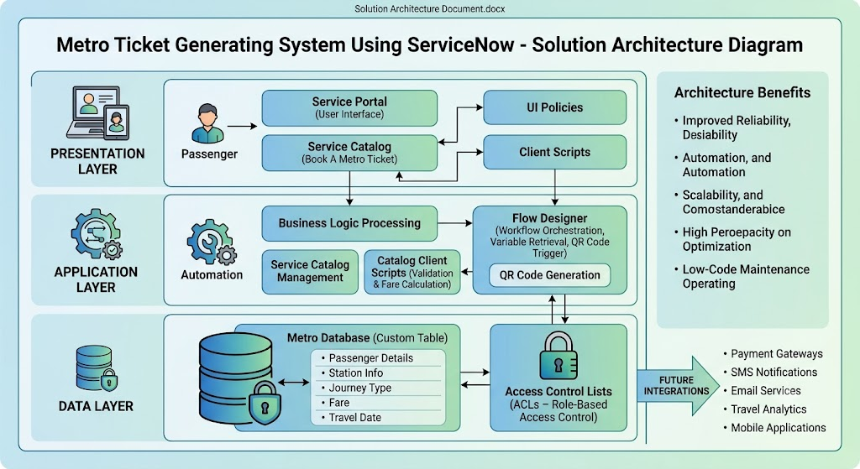

Data Flow
The booking process begins when a passenger opens the Service Portal and completes the booking form. Client Scripts validate the information and calculate the fare automatically. After submission, Flow Designer retrieves the catalog variables and stores them in the Metro Database. Once the booking record is successfully created, the system generates a QR code and displays the booking confirmation to the passenger. Throughout this process, ACLs maintain the security and integrity of booking information.

Architecture Benefits
The proposed architecture improves system reliability by separating user interaction, processing logic, and data storage. Automation reduces manual effort and ensures consistency across all bookings. The architecture is highly scalable, allowing future integration with payment gateways, SMS notifications, email services, travel analytics, and mobile applications. Since the application primarily uses ServiceNow’s low-code features, future maintenance and enhancements can be completed efficiently without extensive coding.

